GitHub Repository Creation

A GitHub repository was created to manage and store the project files. Basic Git commands such as init, add, commit, and push were used to upload the project to GitHub.
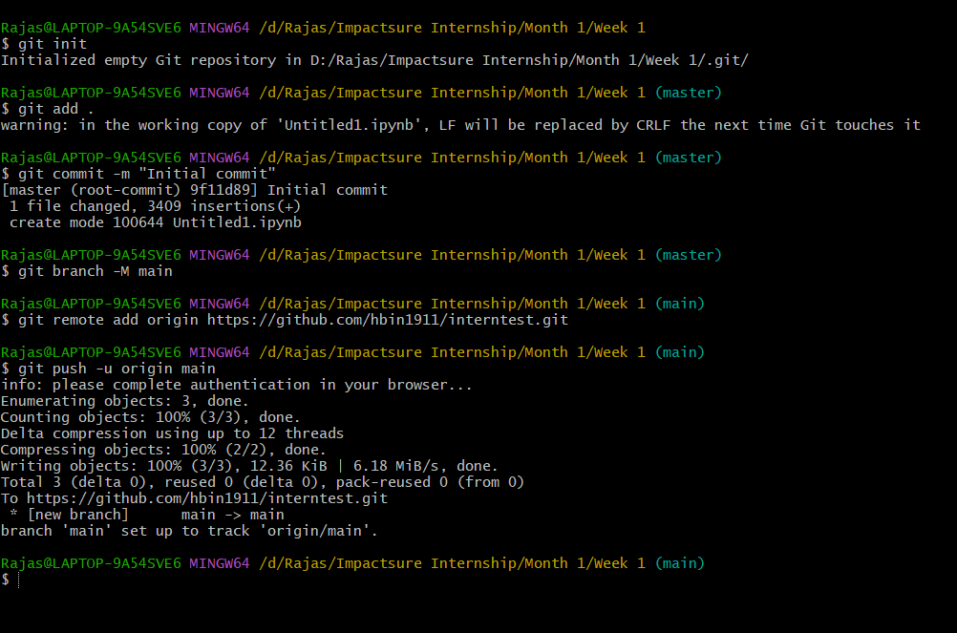

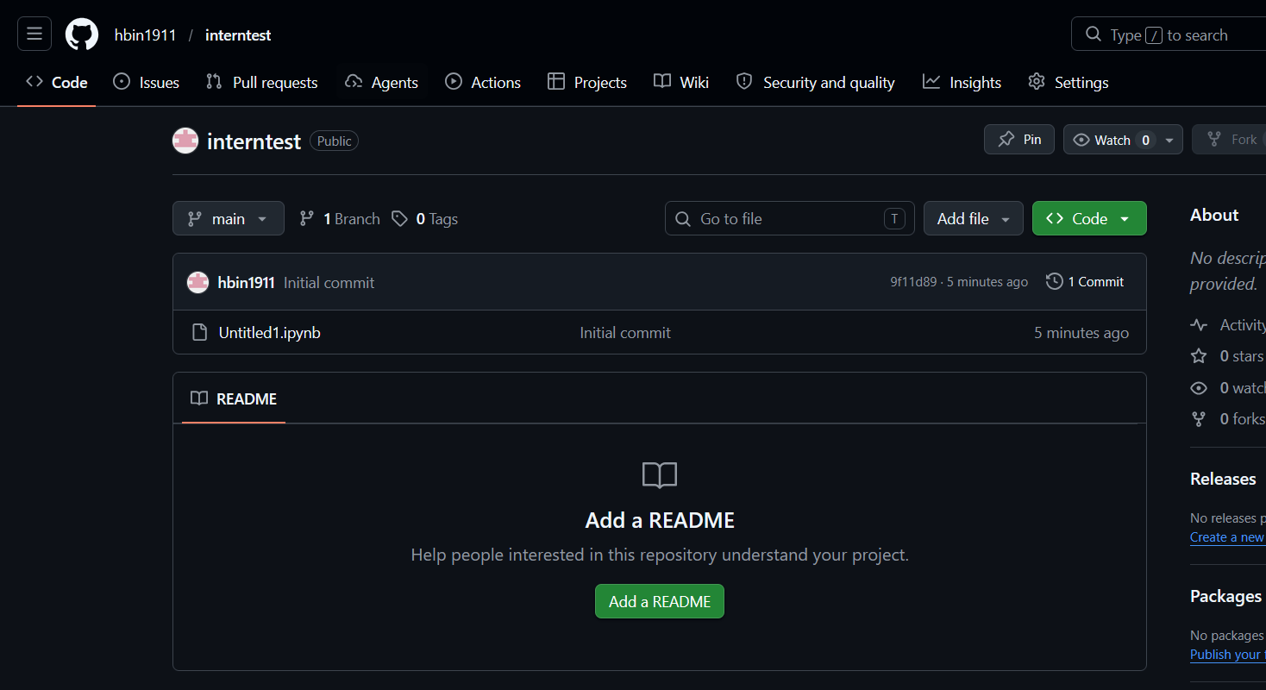
Figure: GitHub repository created and project files uploaded

If you want, you can check the github repo:
https://github.com/hbin1911/interntest

